# CS 255 System Design Document Template

## UML Diagrams

### UML Use Case Diagram

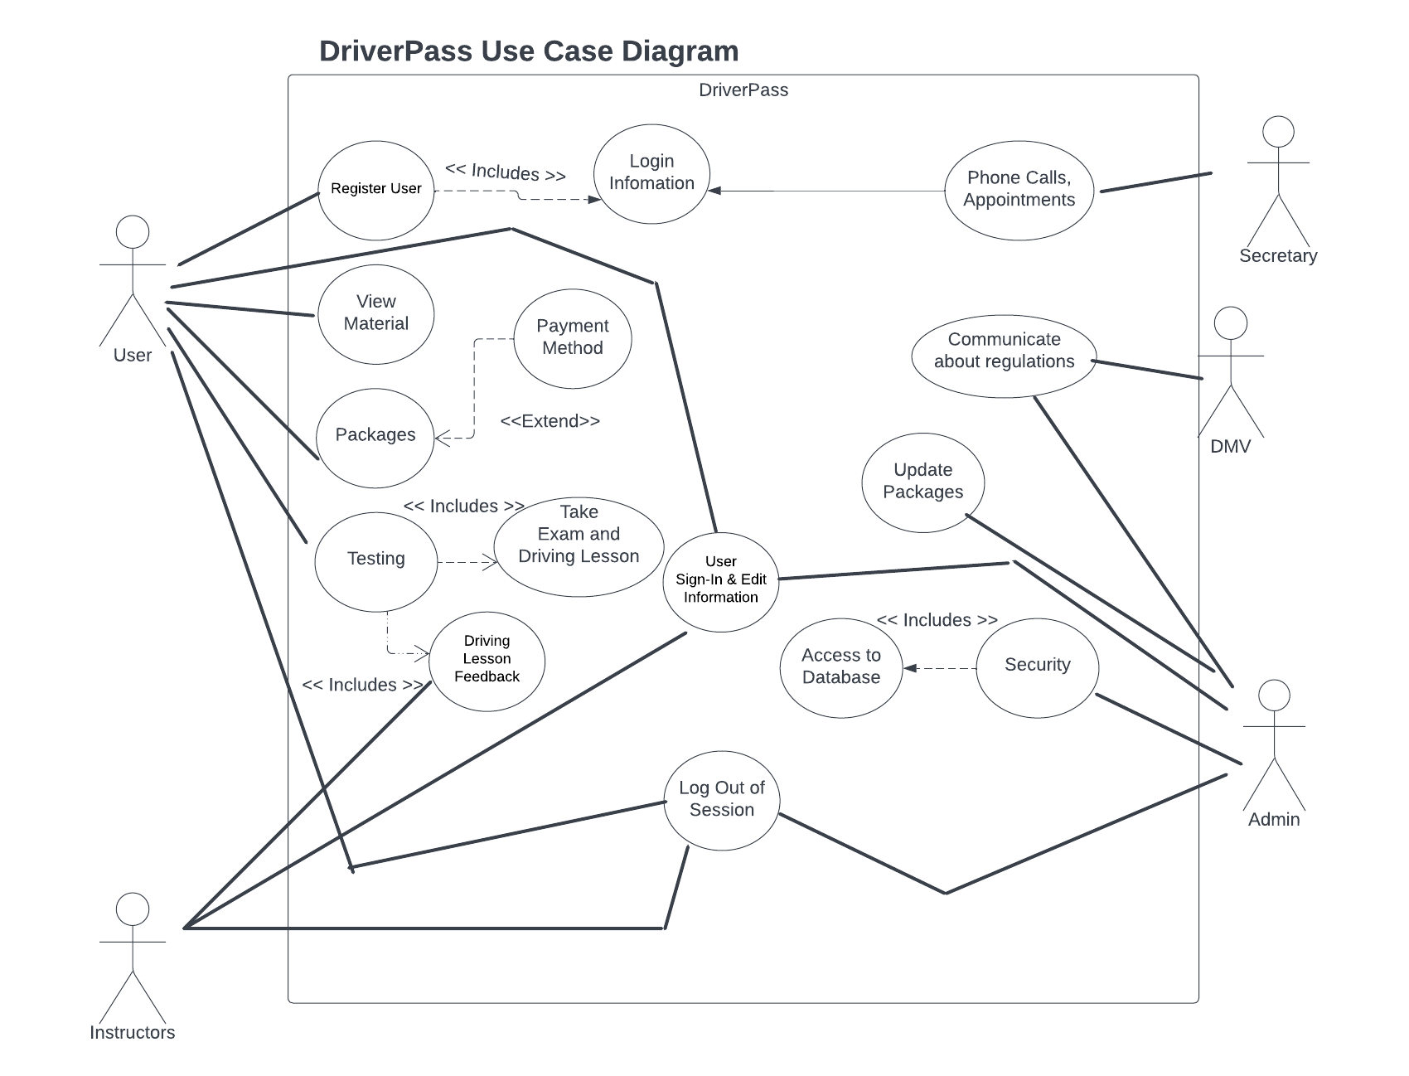

### UML Activity Diagrams

Driver Pass Login

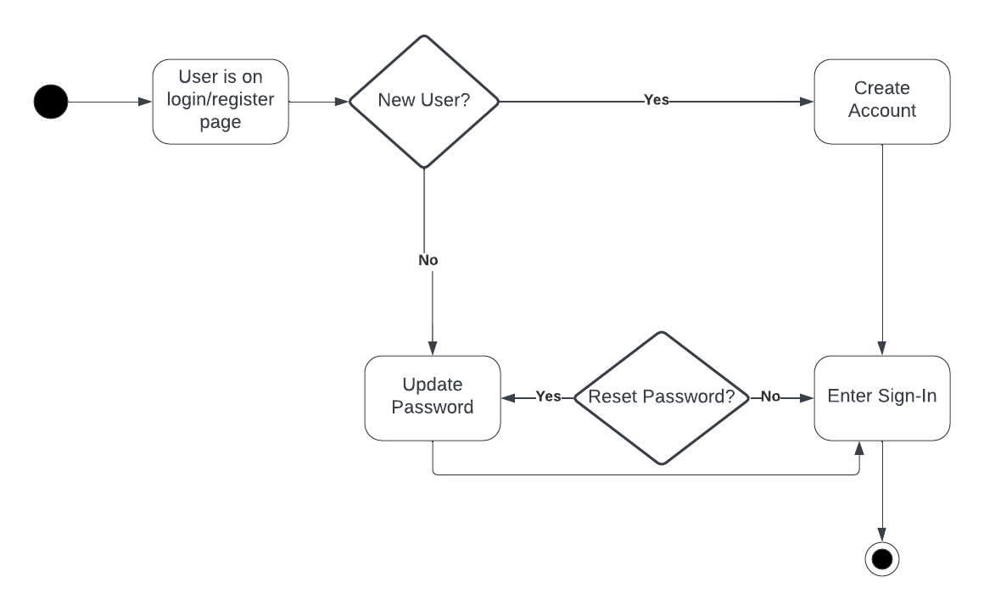

DriverPass Driving Test Registration

### 

### UML Sequence Diagram

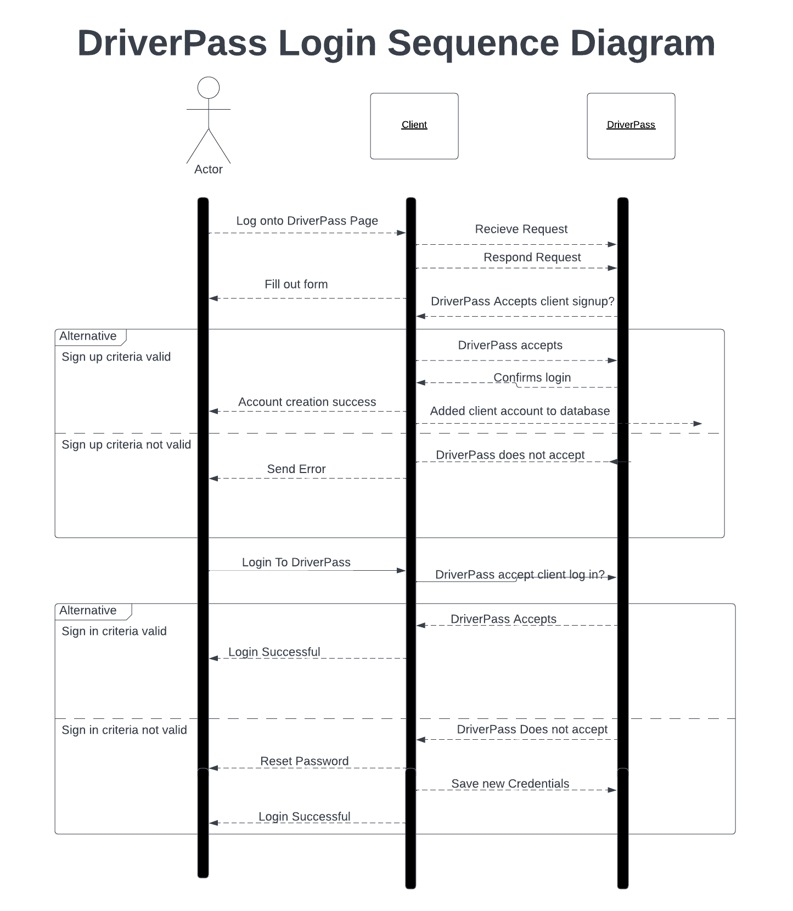

### UML Class Diagram

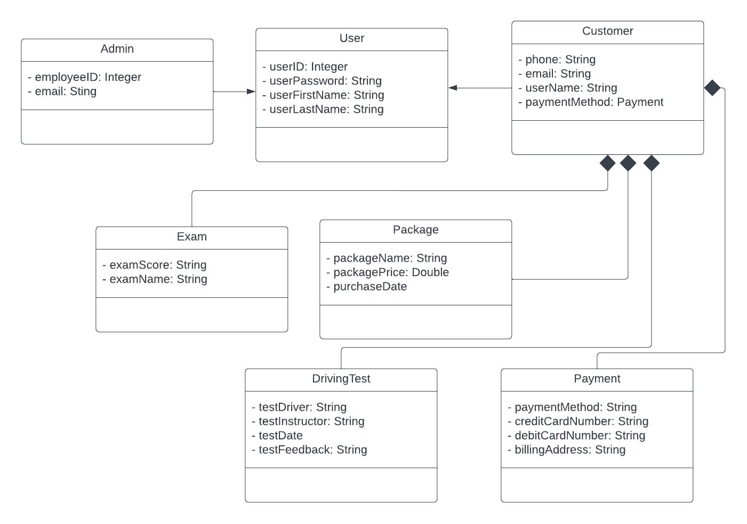

## Technical Requirements

*Hardware*

*Modern Devices can be ran for the client*

* *Desktop*
* *Laptop*
* *Tablet*
* *Smartphone*

*Software*

*Web Browser Compatibility*

* *Chrome*
* *Safari*
* *FireFox*

*Downloadable databases*

* *PDF*

*Tools*

*Lucid Chart*

* *UML Use Case Diagram*
* *UML Sequence Diagram*
* *UML Class Diagram*
* *UML Activity Diagrams*

*Development Tool such as:*

* *Eclipse IDE*
* *Visual Studio*

*Infrastructure*

*Fast, High-speed Wifi*

*Security - Third Party*